To Analyze process abstraction
Execute fork()
Understand exec() family
Analyze parent-child relationships
Inspect process tree
Practice system call tracing

Code:
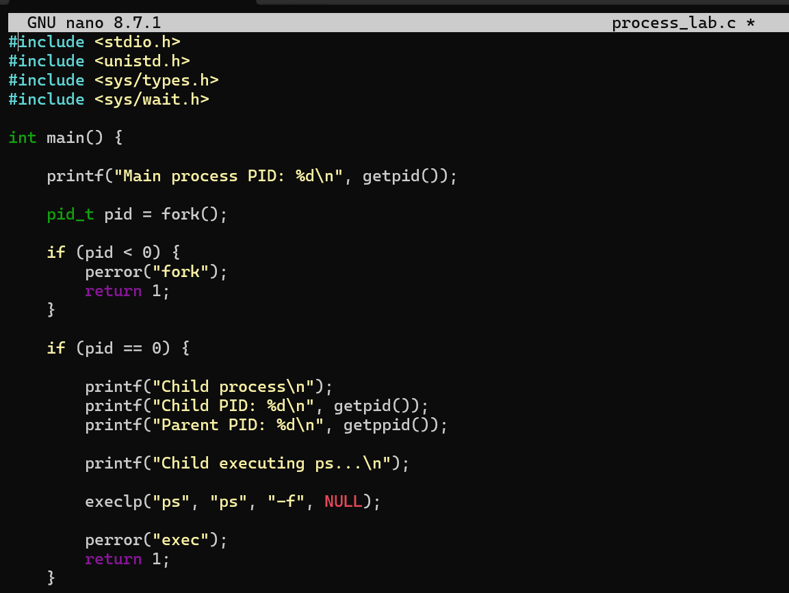
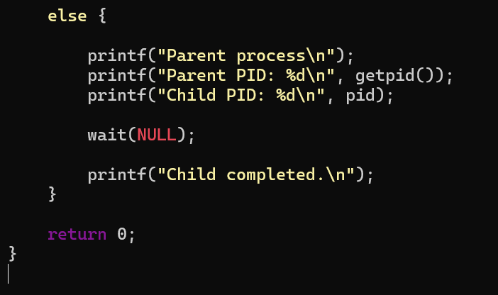
Output:
